JUDGING IMPROMPTU Example Impromptu Ballot 2
JUDGING EXTEMP SPEECHES Example Extemp Ballot 3
JUDGING ORATORY Example Oratory Ballot 4
JUDGING EXPOS Example Expos Ballot 5
JUDGING ED. COMMENTARY Example Ed. Comm. Ballot 6
JUDGING DRAMATIC INTERP Example DI Ballot 7
JUDGING DUAL INTERP Example Dual Interp Ballot 8
JUDGING HUMOROUS INTERP Example HI Ballot 9
JUDGING INTERP READING Example IR Ballot 10

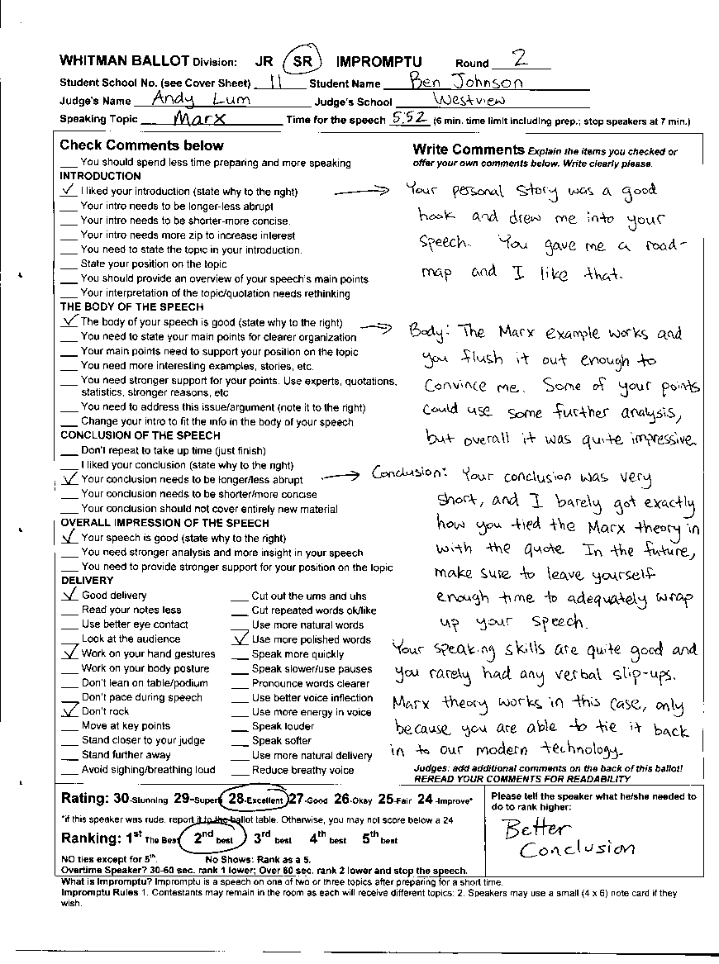
JUDGING IMPROMPTU Example Impromptu Ballot
What is Impromptu? Impromptu is a speech on one of two or three topics after preparing for a short time.
Impromptu Rules 1. Contestants may remain in the room as each will receive different topics; 2. Speakers may use a small (4 x 6) note card.

1. Fill in Info
Circle JR or SR and the Event. Fill in the Round Number, Student’s school and name (see cover sheet for this info.). Fill in your name and school

2. Start the speeches
Note: Other speakers can watch; there are different topics for each speaker.
WHEN THE SPEAKER AND YOU ARE READY: Give the first speaker topics attached to this ballot to the first speaker (give the 2nd speaker topics to the 2nd speaker, etc.). Begin timing when you give the topics to the speaker.
- Note: There may be gaps between speakers. Wait for all speakers unless it is 10 minutes before your ballot is due.
- Give double and triple entered students time and flexibility to do their events. Students do not need to do their speeches in the order listed on the cover sheet.

3. Time each Speaker
6 MINUTES. TIME THE PREPARATION AND SPEECH: When you give the speaker his/her topics, begin timing. Speakers have 6 minutes to read the topics, think about them, and speak. Speakers may divide the time at their discretion.
DURING PREP TIME: Tell the speaker out loud each 30 seconds of prep time that he or she has used.
DURING THE SPEECH: Give time signals with your fingers when the speaker begins speaking. Five fingers means 5 minutes left; four fingers mean 4 minutes left, etc. A finger curled in half means 30 seconds left.
Students who go overtime should be ranked lower as noted below. STOP speakers who go 60 seconds over.

4. Write Comments
PLEASE DON’T . . .
These are the most common complaints we receive about judging. Avoid them!
- Do not make up rules that are not on your ballot. We use WSFA rules and the ballot states the rules (except notes allowed in impromptu).
- Do not change or make up topics. Use the ones provided on your ballot!
- Do not shorten the speaker’s speaking time.
- Do not show favoritism toward particular contestants.
- Do not go to other people to make a decision. You are to make a decision/rank/rate speakers ON YOUR OWN.
- Do not make mean comments on the ballot. Focus on what the speaker did well and what the speaker could improve on.
- Do not comment on a student’s physical looks (either positive or negative—these can easily be conceived of as harassment).
- Do not leave your room until you have heard all speakers or it is 15 minutes before the time when your ballot is due.
- Do not force students to stay in the room. Students may leave for any reason but should do so between speeches.
- Don’t argue against student speeches. Try to help rather than be an opponent against ideas you may not agree with.
- Turn off cell phones, instant messaging, videos, etc. during speeches.

WRITE GOOD BALLOTS!
Please take time to offer students good feedback.
- Be specific.
- Check off items on the ballot and follow them up with specific comments.
- Tell the speaker what he/she did well.
- Tell the speaker what he/she needs to do to do it better; don’t just say he/she did something wrong.
- Keep it positive.
Check the relevant comments and provide explanations in the column to the right. Write your own comments as well.

5. Rate the Speech
After each speech, rate it with a score of 24.1 to 29.9–please use decimals eg 27.7. If a speaker was rude, you can score that person lower after you talk to the ballot table.

6. At the end of the round, Rank the Speeches
After all speakers have spoken, rank the speaker 1 for best, 2 for second best, etc.
NO ties except for 4th.
Circle No Show only if it is 10 min. before the end of the round and the competitor has not shown. Otherwise wait.
Overtime by 60 seconds? Stop the speaker. You may and should rank the speaker 1 lower IF you show the speaking time to the speaker on a timer/stopwatch.
EXAMPLE: A student you would rank as 2nd best goes 60 seconds over: You show her your timer with her time and then you should rank her 3rd and the speaker you would have ranked as 3rd becomes 2nd.

DON’T LEAVE UNLESS ALL SPEAKERS HAVE SPOKEN (unless it is 10 minutes before your ballot is due) Students may arrive as late as 10 minutes before the end of the round.

7. Return your ballot BY
9:50am (Rd 1); 11:30am (Rd 2);
8:30pm (Rd 3); 12:00pm (Finals).
After all speeches have been given, fill out the cover sheet and return your ballots ASAP to the ballot table.

JUDGING EXTEMP SPEECHES Example Extemp Ballot
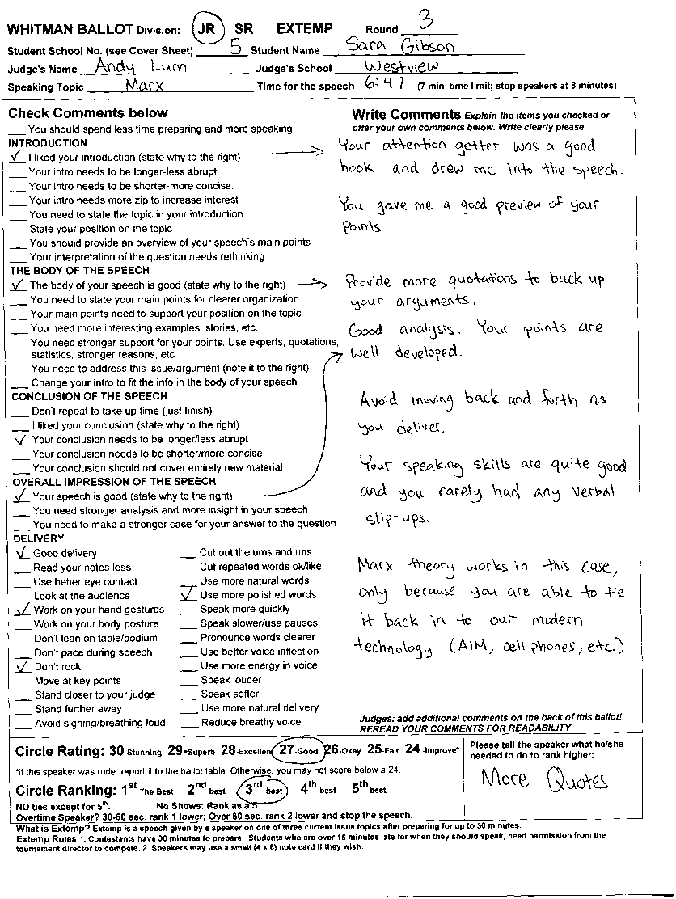
What is Extemp?
Extemp is a speech given by a speaker on one of three current issue topics after preparing for up to 30 minutes.
Extemp Rules
1. Contestants have 30 minutes to prepare. Students who are over 15 minutes late for when they should speak, need permission from the tournament director to compete.
2. Speakers may use a small (4 x 6) note card.

1. Fill in Info
Circle JR or SR; Fill in the Round Number, Student’s school and name (see cover sheet for this info.); Fill in your name and school

2. Start the speeches
Note: Other speakers can watch; there are different topics for each speaker.
First Speaker begins 30 minutes into the round.
WHEN THE SPEAKER AND YOU ARE READY: Tell the speaker to begin and you should begin timing.
- Note: There may be gaps between speakers. Wait for all speakers unless it is 10 minutes before your ballot is due.
- Students do not need to do their speeches in the order listed on the cover sheet BUT IN EXTEMP, they can’t speak later than 45 minutes after their topic was given unless they have tournament director permission.

3. Time each Speaker
7 MINUTES. Extemp Speeches have a time limit of 7 minutes.
Give time signals with your fingers when the speaker begins speaking. Five fingers means 5 minutes left; four fingers mean 4 minutes left, etc. A finger curled in half means 30 seconds left.
Students who go overtime should be ranked lower as noted below. STOP speakers who go 60 or more seconds over.

4. Write Comments
Check the relevant comments and provide explanations in the column to the right. Write your own comments as well.
PLEASE DON’T . . .
Avoid these common complaints we receive about judging.
- Do not make up rules that are not on your ballot. We use WSFA rules and the ballot states the rules (except notes allowed in impromptu).
- Do not change or make up topics. Use the ones provided on your ballot!
- Do not shorten the speaker’s speaking time.
- Do not show favoritism toward particular contestants.
- Do not go to other people to make a decision. You are to make a decision/rank/rate speakers ON YOUR OWN.
- Do not make mean comments on the ballot. Focus on what the speaker did well and what the speaker could improve on.
- Do not comment on a student’s physical looks (either positive or negative—these can easily be conceived of as harassment).
- Do not leave your room until you have heard all speakers or it is 15 minutes before the time when your ballot is due.
- Do not force students to stay in the room. Students may leave for any reason but should do so between speeches.
- Don’t argue against student speeches. Try to help rather than be an opponent against ideas you may not agree with.
- Turn off cell phones, instant messaging, videos, etc. during speeches.

WRITE GOOD BALLOTS!
Please take time to offer students good feedback.
- Be specific.
- Check off items on the ballot and follow them up with specific comments.
- Tell the speaker what he/she did well.
- Tell the speaker what he/she needs to do to do it better; don’t just say he/she did something wrong.

5. Rate the Speech
After each speech, rate it with a score of 24.1 to 29.9–please use decimals eg 27.7. If a speaker was rude, you can score that person lower after you talk to the ballot table.

6. At the end of the round, Rank the Speeches
After all speakers have spoken, rank the speaker 1 for best, 2 for second best, etc.
NO ties except for 4th.
Circle No Show only if it is 10 min. before the end of the round and the competitor has not shown. Otherwise wait.
Overtime by 60 seconds? Stop the speaker. You may and should rank the speaker 1 lower IF you show the speaking time to the speaker on a timer/stopwatch.
EXAMPLE: A student you would rank as 2nd best goes 60 seconds over: You show her your timer with her time and then you should rank her 3rd and the speaker you would have ranked as 3rd becomes 2nd.

DON’T LEAVE UNLESS ALL SPEAKERS HAVE SPOKEN (unless it is 10 minutes before your ballot is due) Students may arrive as late as 10 minutes before the end of the round. Remember, the first speakers starts 30 min. into the round.

7. Return your ballot BY
9:50am (Rd 1); 11:30am (Rd 2);
8:30pm (Rd 3); 12:00pm (Finals).
After all speeches have been given, fill out the cover sheet and return your ballots ASAP to the ballot table.

JUDGING ORATORY Example Oratory Ballot
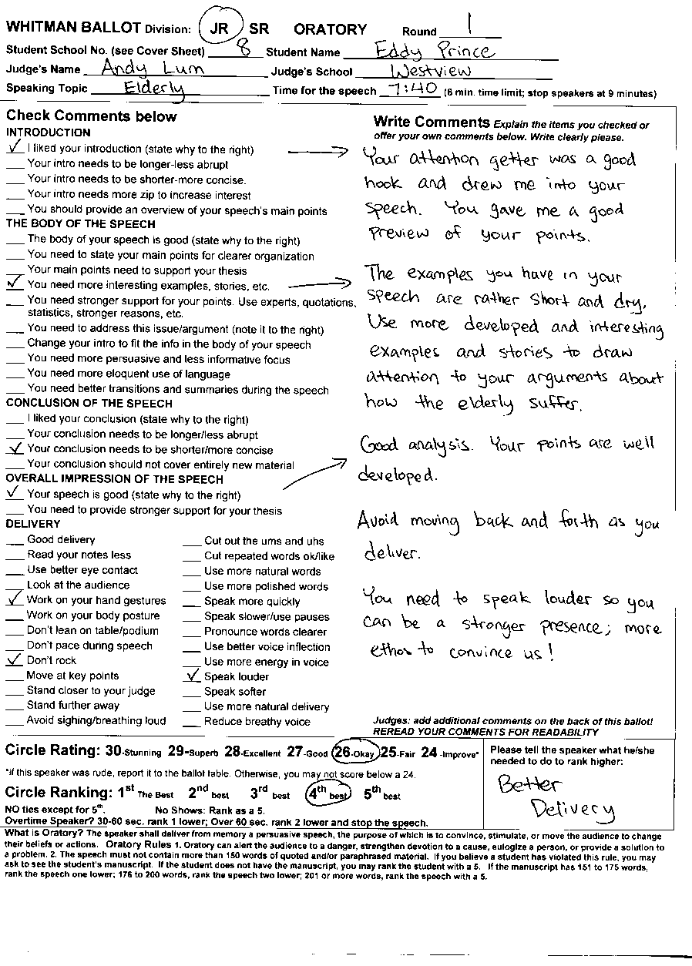
What is Oratory?
The speaker shall deliver from memory a persuasive speech, the purpose of which is to convince, stimulate, or move the audience to change their beliefs or actions.
Oratory Rules
1. Oratory can alert the audience to a danger, strengthen devotion to a cause, eulogize a person, or provide a solution to a problem. 2. The speech must not contain more than 150 words of quoted and/or paraphrased material. If you believe a student has violated this rule, you may ask to see the student’s manuscript. If the student does not have the manuscript, you may rank the student with a 5. If the manuscript has 151 to 175 quoted words, rank the speech one lower; 176 to 200 quoted words, rank the speech two lower; 201 or more quoted words, rank the speech with a 5.

1. Fill in Info
Circle JR or SR; Fill in the Round Number, Student’s school and name (see cover sheet for this info.); Fill in your name and school

2. Start the speeches
WHEN THE SPEAKER AND YOU ARE READY: Tell the speaker to begin and you should begin timing.
- Note: There may be gaps between speakers. Wait for all speakers unless it is 10 minutes before your ballot is due.
- Give double and triple entered students time and flexibility to do their events. Students do not need to do their speeches in the order listed on the cover sheet.

3. Time each Speaker
Oratories have a time limit of 10 minutes.
YOU DO NOT GIVE TIME SIGNALS IN ORATORY.
Students who go overtime should be ranked lower as noted below. STOP speakers who go 60 or more seconds over.

4. Write Comments
Check the relevant comments and provide explanations in the column to the right. Write your own comments as well.

5. Rate the Speech
PLEASE DON’T . . .
These are the most common complaints we receive about judging. Avoid them!
- Do not make up rules that are not on your ballot. We use WSFA rules and the ballot states the rules (except notes allowed in impromptu).
- Don’t argue against student speeches. Try to help rather than be an opponent against ideas you may not agree with.
- Do not shorten the speaker’s speaking time.
- Do not show favoritism toward particular contestants.
- Do not go to other people to make a decision. You are to make a decision/rank/rate speakers ON YOUR OWN.
- Do not make mean comments on the ballot. Focus on what the speaker did well and what the speaker could improve on.
- Do not comment on a student’s physical looks (either positive or negative—these can easily be conceived of as harassment).
- Do not leave your room until you have heard all speakers or it is 15 minutes before the time when your ballot is due.
- Do not force students to stay in the room. Students may leave for any reason but should do so between speeches.
- Turn off cell phones, instant messaging, videos, etc. during speeches.

WRITE GOOD BALLOTS!
Please take time to offer students good feedback.
- Be specific.
- Check off items on the ballot and follow them up with specific comments.
- Tell the speaker what he/she did well.
- Tell the speaker what he/she needs to do to do it better; don’t just say he/she did something wrong.
- Keep it positive.
After each speech, rate it with a score of 24.1 to 29.9–please use decimals eg 27.7. If a speaker was rude, you can score that person lower after you talk to the ballot table.

6. At the end of the round, Rank the Speeches
After all speakers have spoken, rank the speaker 1 for best, 2 for second best, etc.
NO ties except for 4th.
Circle No Show only if it is 10 min. before the end of the round and the competitor has not shown. Otherwise wait.
Overtime by 60 seconds? Stop the speaker. You may and should rank the speaker 1 lower IF you show the speaking time to the speaker on a timer/stopwatch.
EXAMPLE: A student you would rank as 2nd best goes 60 seconds over: You show her your timer with her time and then you should rank her 3rd and the speaker you would have ranked as 3rd becomes 2nd.

DON’T LEAVE UNLESS ALL SPEAKERS HAVE SPOKEN (unless it is 10 minutes before your ballot is due) Students may arrive as late as 10 minutes before the end of the round.

7. Return your ballot BY
9:50am (Rd 1); 11:30am (Rd 2);
8:30pm (Rd 3); 12:00pm (Finals).
After all speeches have been given, fill out the cover sheet and return your ballots ASAP to the ballot table.

JUDGING EXPOS Example Expos Ballot
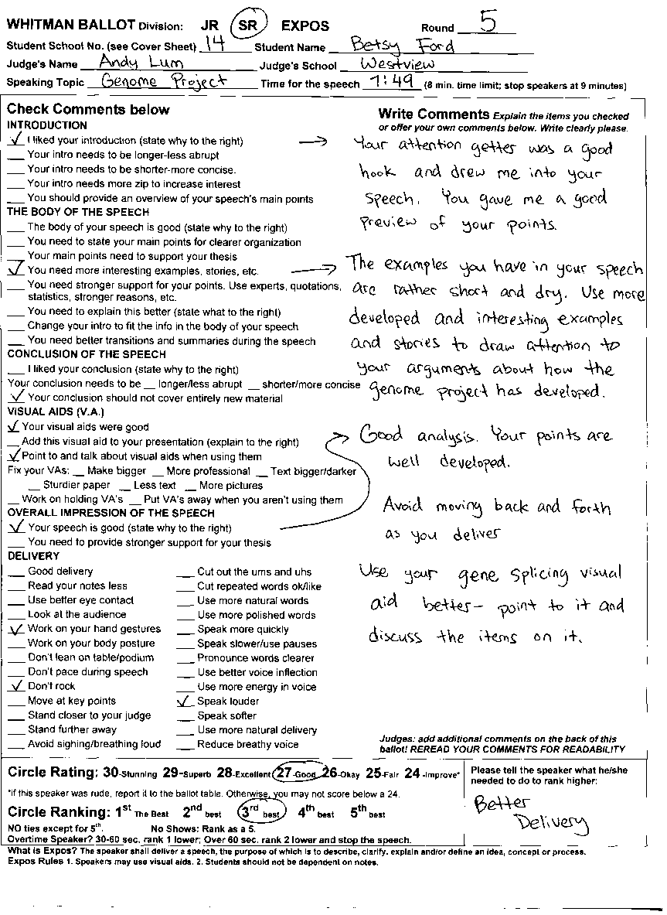
What is Expos?
The speaker shall deliver a speech, the purpose of which is to describe, clarify, explain and/or define an idea, concept or process.
Expos Rules
1. Speakers may use visual aids.
2. Students should not be dependent on notes although they are permitted.

1. Fill in Info
Circle JR or SR; Fill in the Round Number, Student’s school and name (see cover sheet for this info.); Fill in your name and school

2. Start the speeches
WHEN THE SPEAKER AND YOU ARE READY: Tell the speaker to begin and you should begin timing.
- Note: There may be gaps between speakers. Wait for all speakers unless it is 10 minutes before your ballot is due.
- Give double and triple entered students and late debaters time and flexibility to do their events. Students do not need to do their speeches in the order listed on the cover sheet.

3. Time each Speaker
Expos Speeches have a time limit of 8 minutes. YOU DO NOT GIVE TIME SIGNALS IN EXPOS. Students who go overtime should be ranked lower as noted below. STOP speakers who go 60 or more seconds over.

4. Write Comments
Check the relevant comments and provide explanations in the column to the right. Write your own comments as well.

5. Rate the Speech
After each speech, rate it with a score of 24.1 to 29.9–please use decimals eg 27.7. If a speaker was rude, you can score that person lower after you talk to the ballot table.

6. At the end of the round, Rank the Speeches
PLEASE DON’T . . .
These are the most common complaints we receive about judging. Avoid them!
- Do not make up rules that are not on your ballot. We use WSFA rules and the ballot states the rules (except notes allowed in impromptu).
- Don’t argue against student speeches. Try to help rather than be an opponent against ideas you may not agree with.
- Do not shorten the speaker’s speaking time.
- Do not show favoritism toward particular contestants.
- Do not go to other people to make a decision. You are to make a decision/rank/rate speakers ON YOUR OWN.
- Do not make mean comments on the ballot. Focus on what the speaker did well and what the speaker could improve on.
- Do not comment on a student’s physical looks (either positive or negative—these can easily be conceived of as harassment).
- Do not leave your room until you have heard all speakers or it is 15 minutes before the time when your ballot is due.
- Do not force students to stay in the room. Students may leave for any reason but should do so between speeches.
- Turn off cell phones, instant messaging, videos, etc. during speeches.

WRITE GOOD BALLOTS!
Please take time to offer students good feedback.
- Be specific.
- Check off items on the ballot and follow them up with specific comments.
- Tell the speaker what he/she did well.
- Tell the speaker what he/she needs to do to do it better; don’t just say he/she did something wrong.
- Keep it positive.
After all speakers have spoken, rank the speaker 1 for best, 2 for second best, etc.
NO ties except for 4th.
Circle No Show only if it is 10 min. before the end of the round and the competitor has not shown. Otherwise wait.
Overtime by 60 seconds? Stop the speaker. You may and should rank the speaker 1 lower IF you show the speaking time to the speaker on a timer/stopwatch.
EXAMPLE: A student you would rank as 2nd best goes 60 seconds over: You show her your timer with her time and then you should rank her 3rd and the speaker you would have ranked as 3rd becomes 2nd.

DON’T LEAVE UNLESS ALL SPEAKERS HAVE SPOKEN (unless it is 10 minutes before your ballot is due) Students may arrive as late as 10 minutes before the end of the round.

7. Return your ballot BY
9:50am (Rd 1); 11:30am (Rd 2);
8:30pm (Rd 3); 12:00pm (Finals).
After all speeches have been given, fill out the cover sheet and return your ballots ASAP to the ballot table.

JUDGING ED. COMMENTARY Example Ed. Comm. Ballot
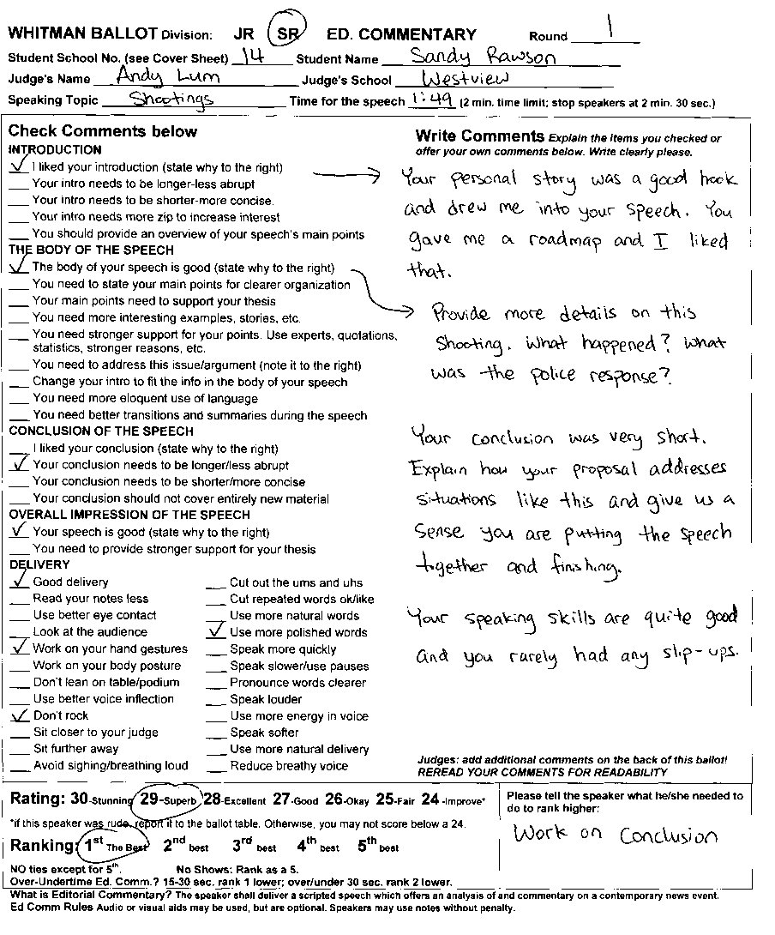
What is Editorial Commentary?
The speaker shall deliver a scripted speech which offers an analysis of and commentary on a contemporary news event.
Ed Comm Rules
Audio or visual aids may be used, but are optional.
Speakers may use notes without penalty.
SPEAKERS DO LOOK AT THE JUDGE—This is not Radio Comm.

1. Fill in Info
Circle JR or SR; Fill in the Round Number, Student’s school and name (see cover sheet for this info.); Fill in your name and school

2. Start the speeches
WHEN THE SPEAKER AND YOU ARE READY: Tell the speaker to begin and you should begin timing.
- Note: There may be gaps between speakers. Wait for all speakers unless it is 10 minutes before your ballot is due.
- Give double and triple entered students time and flexibility to do their events. Students do not need to do their speeches in the order listed on the cover sheet.
- ED. COMM. SPEAKERS SIT WHEN PRESENTING.

3. Time each Speaker
Editorial Commentary speeches should be 1 minute 45 seconds to 2 minutes.
YOU DO NOT GIVE TIME SIGNALS IN ED. COMM.
Students who go under or overtime in Editorial Commentary should be ranked lower as noted below. STOP speakers who go 30 or more seconds over.

4. Write Comments
Check the relevant comments and provide explanations in the column to the right. Write your own comments as well.
PLEASE DON’T . . .
These are the most common complaints we receive about judging. Avoid them!
- Do not make up rules that are not on your ballot. We use WSFA rules and the ballot states the rules (except notes allowed in impromptu).
- Don’t argue against student speeches. Try to help rather than be an opponent against ideas you may not agree with.
- Do not shorten the speaker’s speaking time.
- Do not show favoritism toward particular contestants.
- Do not go to other people to make a decision. You are to make a decision/rank/rate speakers ON YOUR OWN.
- Do not make mean comments on the ballot. Focus on what the speaker did well and what the speaker could improve on.
- Do not comment on a student’s physical looks (either positive or negative—these can easily be conceived of as harassment).
- Do not leave your room until you have heard all speakers or it is 15 minutes before the time when your ballot is due.
- Do not force students to stay in the room. Students may leave for any reason but should do so between speeches.
- Turn off cell phones, instant messaging, videos, etc. during speeches.

WRITE GOOD BALLOTS!
Please take time to offer students good feedback.
- Be specific.
- Check off items on the ballot and follow them up with specific comments.
- Tell the speaker what he/she did well.
- Tell the speaker what he/she needs to do to do it better; don’t just say he/she did something wrong.
- Keep it positive.

5. Rate the Speech
After each speech, rate it with a score of 24.1 to 29.9–please use decimals eg 27.7. If a speaker was rude, you can score that person lower after you talk to the ballot table.

6. At the end of the round, Rank the Speeches
After all speakers have spoken, rank the speaker 1 for best, 2 for second best, etc.
NO ties except for 4th.
Circle No Show only if it is 10 min. before the end of the round and the competitor has not shown. Otherwise wait.
Overtime by 30 seconds in Ed Comm? Stop the speaker. You may and should rank the speaker 1 lower IF you show the speaking time to the speaker on a timer/stopwatch.
EXAMPLE: A student you would rank as 2nd best goes 60 seconds over: You show her your timer with her time and then you should rank her 3rd and the speaker you would have ranked as 3rd becomes 2nd.

DON’T LEAVE UNLESS ALL SPEAKERS HAVE SPOKEN (unless it is 10 minutes before your ballot is due) Students may arrive as late as 10 minutes before the end of the round.

7. Return your ballot BY
9:50am (Rd 1); 11:30am (Rd 2);
8:30pm (Rd 3); 12:00pm (Finals).
After all speeches have been given, fill out the cover sheet and return your ballots ASAP to the ballot table.

JUDGING DRAMATIC INTERP Example DI Ballot
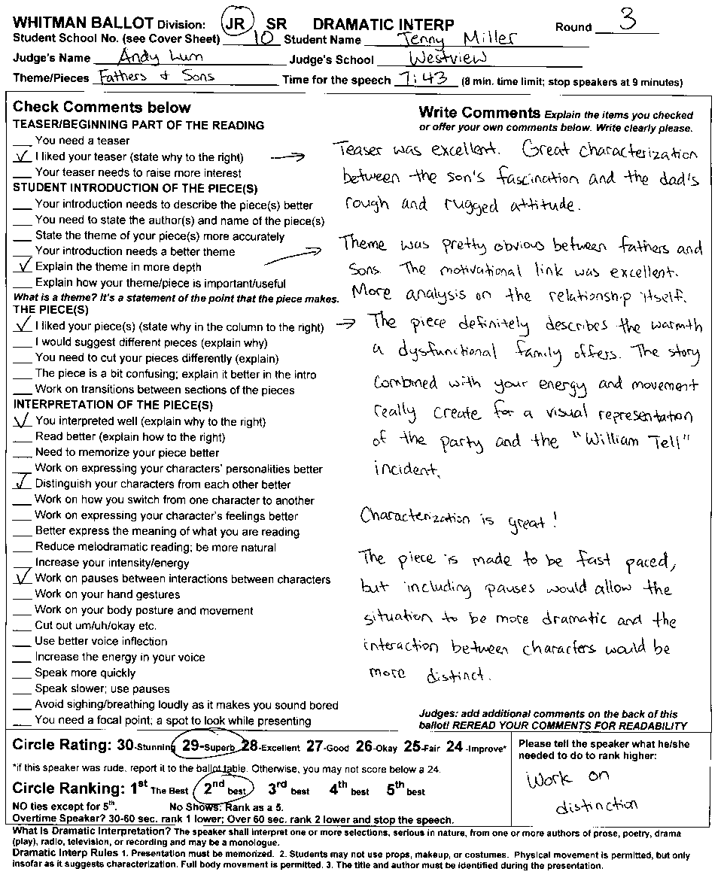
Dramatic Interp Rules
1. Presentation must be memorized.
2. Students may not use props, make up, or costumes.
3. Physical movement is permitted, but only insofar as it suggests characterization. Full body movement is permitted.
4. The title and author must be identified during the presentation.
Please stop students from screaming/shouting loudly.

1. Fill in Info
Circle JR or SR; Fill in the Round Number, Student’s school and name (see cover sheet for this info.); Fill in your name and school

2. Start the speeches
WHEN THE SPEAKER AND YOU ARE READY: Tell the speaker to begin and you should begin timing.
- Note: There may be gaps between speakers. Wait for all speakers unless it is 10 minutes before your ballot is due.
- Give double and triple entered students time and flexibility to do their events. Students do not need to do their speeches in the order listed on the cover sheet.

3. Time each Speaker
Dramatic Interp has a time limit of 10 minutes. YOU DO NOT GIVE TIME SIGNALS IN DRAMATIC INTERP. Students who go overtime should be ranked lower as noted below. STOP speakers who go 60 or more seconds over.

4. Write Comments
Check the relevant comments and provide explanations in the column to the right. Write your own comments as well.

5. Rate the Speech
After each speech, rate it with a score of 24.1 to 29.9–please use decimals eg 27.7. If a speaker was rude, you can score that person lower after you talk to the ballot table.
PLEASE DON’T . . .
These are the most common complaints we receive about judging. Avoid them!
- Do not make up rules that are not on your ballot. We use WSFA rules and the ballot states the rules (except notes allowed in impromptu).
- Don’t argue against student speeches. Try to help rather than be an opponent against ideas you may not agree with.
- Do not shorten the speaker’s speaking time.
- Do not show favoritism toward particular contestants.
- Do not go to other people to make a decision. You are to make a decision/rank/rate speakers ON YOUR OWN.
- Do not make mean comments on the ballot. Focus on what the speaker did well and what the speaker could improve on.
- Do not comment on a student’s physical looks (either positive or negative—these can easily be conceived of as harassment).
- Do not leave your room until you have heard all speakers or it is 15 minutes before the time when your ballot is due.
- Do not force students to stay in the room. Students may leave for any reason but should do so between speeches.
- Turn off cell phones, instant messaging, videos, etc. during speeches.

WRITE GOOD BALLOTS!
Please take time to offer students good feedback.
- Be specific.
- Check off items on the ballot and follow them up with specific comments.
- Tell the speaker what he/she did well.
- Tell the speaker what he/she needs to do to do it better; don’t just say he/she did something wrong.
- Keep it positive.
6. At the end of the round, Rank the Speeches
After all speakers have spoken, rank the speaker 1 for best, 2 for second best, etc.
NO ties except for 4th.
Circle No Show only if it is 10 min. before the end of the round and the competitor has not shown. Otherwise wait.
Overtime by 60 seconds? Stop the speaker. You may and should rank the speaker 1 lower IF you show the speaking time to the speaker on a timer/stopwatch.
EXAMPLE: A student you would rank as 2nd best goes 60 seconds over: You show her your timer with her time and then you should rank her 3rd and the speaker you would have ranked as 3rd becomes 2nd.

DON’T LEAVE UNLESS ALL SPEAKERS HAVE SPOKEN (unless it is 10 minutes before your ballot is due) Students may arrive as late as 10 minutes before the end of the round.

7. Return your ballot BY
9:50am (Rd 1); 11:30am (Rd 2);
8:30pm (Rd 3); 12:00pm (Finals).
After all speeches have been given, fill out the cover sheet and return your ballots ASAP to the ballot table.

JUDGING DUAL INTERP Example Dual Interp Ballot
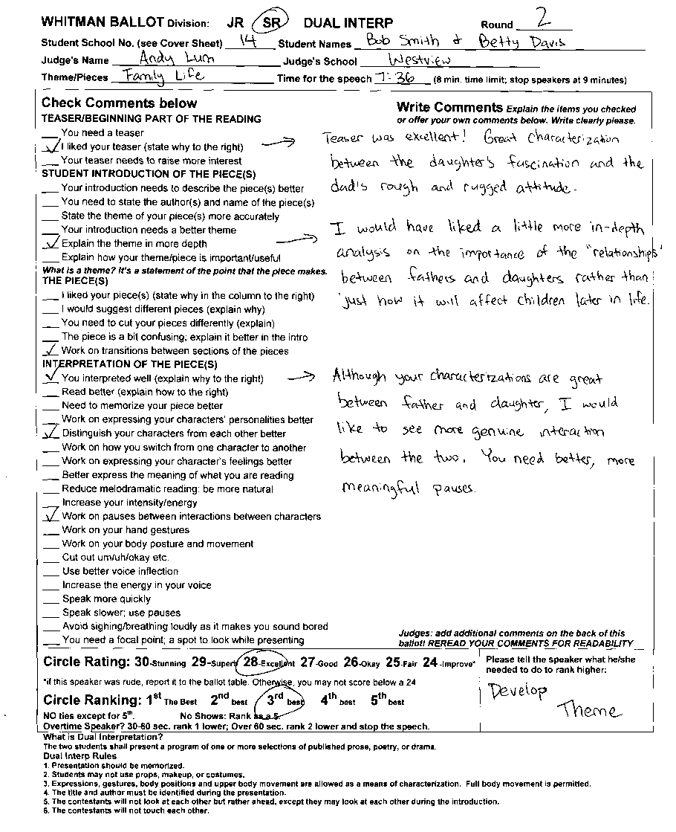
What is Dual Interpretation?
The two students shall present a program of one or more selections of published prose, poetry, or drama.
Dual Interp Rules
1. Presentation should be memorized.
2. Students may not use props, make up, or costumes.
3. Expressions, gestures, body positions and upper body movement are allowed as a means of characterization. Full body movement is permitted.
4. The title and author must be identified during the presentation.
5. The contestants will not look at each other but rather ahead, except they may look at each other during the introduction.
6. The contestants will not touch each other.
Please stop students from screaming/shouting loudly.

1. Fill in Info
Circle JR or SR; Fill in the Round Number, Student’s school and name (see cover sheet for this info.); Fill in your name and school

2. Start the speeches
WHEN THE SPEAKER AND YOU ARE READY: Tell the speaker to begin and you should begin timing.
- Note: There may be gaps between speakers. Wait for all speakers unless it is 10 minutes before your ballot is due.
- Give double and triple entered students time and flexibility to do their events. Students do not need to do their speeches in the order listed on the cover sheet.

3. Time each Speaker
Dual Interpretation has a time limit of 10 minutes. YOU DO NOT GIVE TIME SIGNALS IN DUAL INTERPRETATION. Students who go overtime should be ranked lower as noted below. STOP speakers who go 60 or more seconds over.

4. Write Comments
Check the relevant comments and provide explanations in the column to the right. Write your own comments as well.
PLEASE DON’T . . .
These are the most common complaints we receive about judging. Avoid them!
- Do not make up rules that are not on your ballot. We use WSFA rules and the ballot states the rules (except notes allowed in impromptu).
- Don’t argue against student speeches. Try to help rather than be an opponent against ideas you may not agree with.
- Do not shorten the speaker’s speaking time.
- Do not show favoritism toward particular contestants.
- Do not go to other people to make a decision. You are to make a decision/rank/rate speakers ON YOUR OWN.
- Do not make mean comments on the ballot. Focus on what the speaker did well and what the speaker could improve on.
- Do not comment on a student’s physical looks (either positive or negative—these can easily be conceived of as harassment).
- Do not leave your room until you have heard all speakers or it is 15 minutes before the time when your ballot is due.
- Do not force students to stay in the room. Students may leave for any reason but should do so between speeches.
- Turn off cell phones, instant messaging, videos, etc. during speeches.

WRITE GOOD BALLOTS!
Please take time to offer students good feedback.
- Be specific.
- Check off items on the ballot and follow them up with specific comments.
- Tell the speaker what he/she did well.
- Tell the speaker what he/she needs to do to do it better; don’t just say he/she did something wrong.
- Keep it positive.

5. Rate the Speech
After each speech, rate it with a score of 24.1 to 29.9–please use decimals eg 27.7. If a speaker was rude, you can score that person lower after you talk to the ballot table.

6. At the end of the round, Rank the Speeches
After all speakers have spoken, rank the speaker 1 for best, 2 for second best, etc.
NO ties except for 4th.
Circle No Show only if it is 10 min. before the end of the round and the competitor has not shown. Otherwise wait.
Overtime by 60 seconds? Stop the speaker. You may and should rank the speaker 1 lower IF you show the speaking time to the speaker on a timer/stopwatch.
EXAMPLE: A student you would rank as 2nd best goes 60 seconds over: You show her your timer with her time and then you should rank her 3rd and the speaker you would have ranked as 3rd becomes 2nd.
DON’T LEAVE UNLESS ALL SPEAKERS HAVE SPOKEN (unless it is 10 minutes before your ballot is due) Students may arrive as late as 10 minutes before the end of the round.

7. Return your ballot BY
9:50am (Rd 1); 11:30am (Rd 2);
8:30pm (Rd 3); 12:00pm (Finals).
After all speeches have been given, fill out the cover sheet and return your ballots ASAP to the ballot table.

JUDGING HUMOROUS INTERP Example HI Ballot
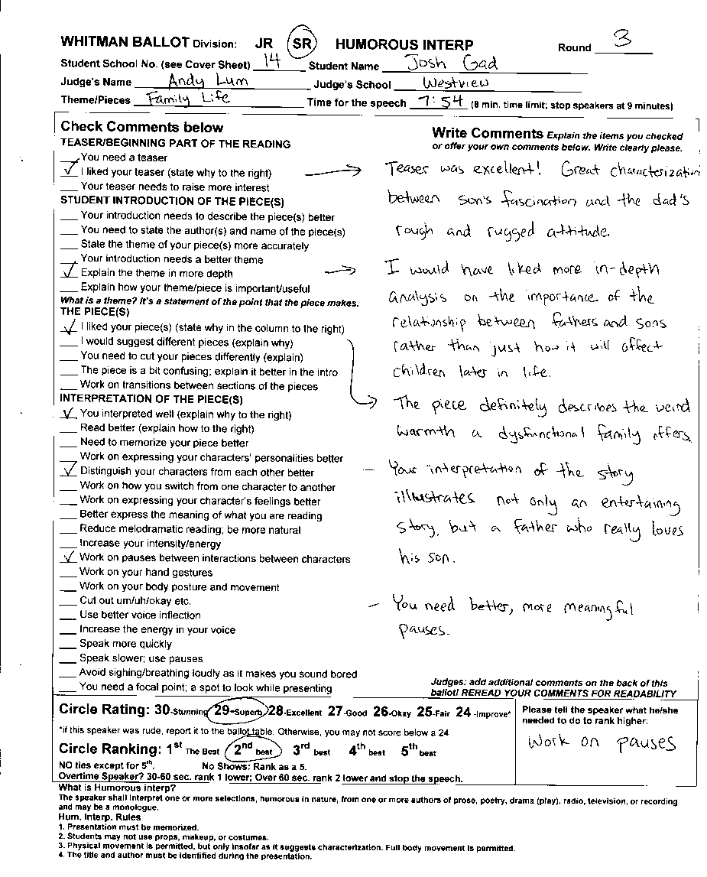
What is Humorous interp?
The speaker shall interpret one or more selections, humorous in nature, from one or more authors of prose, poetry, drama (play), radio, television, or recording and may be a monologue.
Hum. Interp. Rules
1. Presentation must be memorized.
2. Students may not use props, make up, or costumes.
3. Physical movement is permitted, but only insofar as it suggests characterization. Full body movement is permitted.
4. The title and author must be identified during the presentation.
Please stop students from screaming/shouting loudly.

1. Fill in Info
Circle JR or SR; Fill in the Round Number, Student’s school and name (see cover sheet for this info.); Fill in your name and school

2. Start the speeches
WHEN THE SPEAKER AND YOU ARE READY: Tell the speaker to begin and you should begin timing.
- Note: There may be gaps between speakers. Wait for all speakers unless it is 10 minutes before your ballot is due.
- Give double and triple entered students time and flexibility to do their events. Students do not need to do their speeches in the order listed on the cover sheet.

3. Time each Speaker
Humorous Interpretation has a time limit of 10 minutes. YOU DO NOT GIVE TIME SIGNALS IN HUMOROUS INTERPRETATION. Students who go overtime should be ranked lower as noted below. STOP speakers who go 60 or more seconds over.

4. Write Comments
Check the relevant comments and provide explanations in the column to the right. Write your own comments as well.
PLEASE DON’T . . .
These are the most common complaints we receive about judging. Avoid them!
- Do not make up rules that are not on your ballot. We use WSFA rules and the ballot states the rules (except notes allowed in impromptu).
- Don’t argue against student speeches. Try to help rather than be an opponent against ideas you may not agree with.
- Do not shorten the speaker’s speaking time.
- Do not show favoritism toward particular contestants.
- Do not go to other people to make a decision. You are to make a decision/rank/rate speakers ON YOUR OWN.
- Do not make mean comments on the ballot. Focus on what the speaker did well and what the speaker could improve on.
- Do not comment on a student’s physical looks (either positive or negative—these can easily be conceived of as harassment).
- Do not leave your room until you have heard all speakers or it is 15 minutes before the time when your ballot is due.
- Do not force students to stay in the room. Students may leave for any reason but should do so between speeches.
- Turn off cell phones, instant messaging, videos, etc. during speeches.

WRITE GOOD BALLOTS!
Please take time to offer students good feedback.
- Be specific.
- Check off items on the ballot and follow them up with specific comments.
- Tell the speaker what he/she did well.
- Tell the speaker what he/she needs to do to do it better; don’t just say he/she did something wrong.
- Keep it positive.
5. Rate the Speech
After each speech, rate it with a score of 24.1 to 29.9–please use decimals eg 27.7. If a speaker was rude, you can score that person lower after you talk to the ballot table.

6. At the end of the round, Rank the Speeches
After all speakers have spoken, rank the speaker 1 for best, 2 for second best, etc.
NO ties except for 4th.
Circle No Show only if it is 10 min. before the end of the round and the competitor has not shown. Otherwise wait.
Overtime by 60 seconds? Stop the speaker. You may and should rank the speaker 1 lower IF you show the speaking time to the speaker on a timer/stopwatch.
EXAMPLE: A student you would rank as 2nd best goes 60 seconds over: You show her your timer with her time and then you should rank her 3rd and the speaker you would have ranked as 3rd becomes 2nd.

DON’T LEAVE UNLESS ALL SPEAKERS HAVE SPOKEN (unless it is 10 minutes before your ballot is due) Students may arrive as late as 10 minutes before the end of the round.

7. Return your ballot BY
9:50am (Rd 1); 11:30am (Rd 2);
8:30pm (Rd 3); 12:00pm (Finals).
After all speeches have been given, fill out the cover sheet and return your ballots ASAP to the ballot table.

JUDGING INTERP READING Example IR Ballot
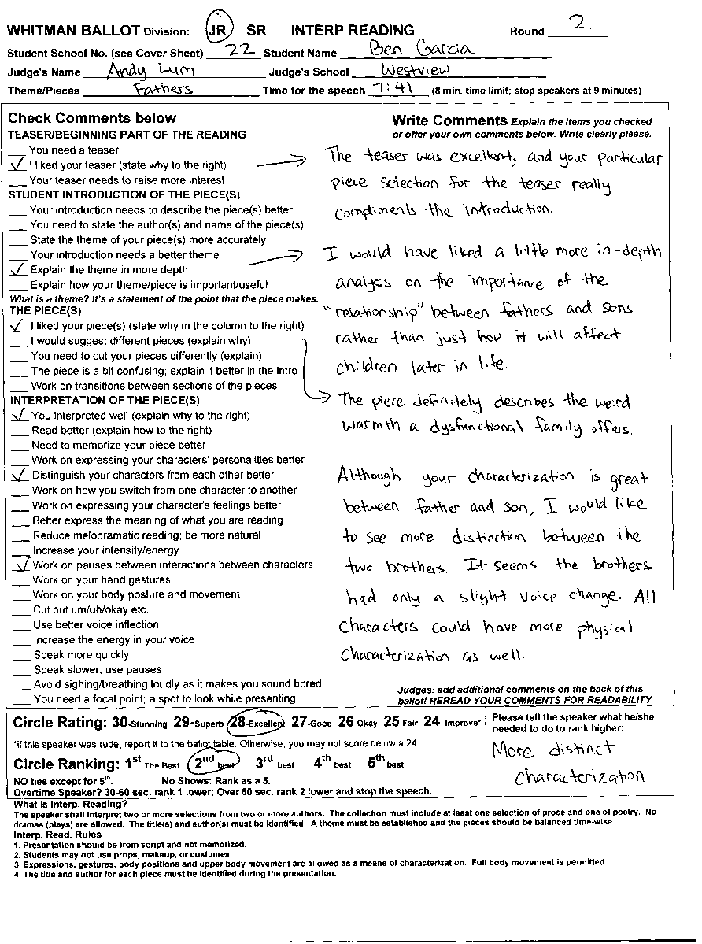
What is Interp. Reading?
The speaker shall interpret two or more selections from two or more authors. The collection must include at least one selection of prose and one of poetry. No dramas (plays) are allowed. The title(s) and author(s) must be identified. A theme must be established and the pieces should be balanced time-wise.
Interp. Reading Rules
1. Presentation should be from script and not memorized.
2. Students may not use props, make up, or costumes.
3. Expressions, gestures, body positions and upper body movement are allowed as a means of characterization. Full body movement is permitted.
4. The title and author for each piece must be identified during the presentation.
Please stop students from screaming/shouting loudly.

1. Fill in Info
Circle JR or SR; Fill in the Round Number, Student’s school and name (see cover sheet for this info.); Fill in your name and school

2. Start the speeches
WHEN THE SPEAKER AND YOU ARE READY: Tell the speaker to begin and you should begin timing.
- Note: There may be gaps between speakers. Wait for all speakers unless it is 10 minutes before your ballot is due.
- Give double and triple entered students time and flexibility to do their events. Students do not need to do their speeches in the order listed on the cover sheet.

3. Time each Speaker
Interp Reading has a time limit of 8 minutes. YOU DO NOT GIVE TIME SIGNALS IN INTERP READING. Students who go overtime should be ranked lower as noted below. STOP speakers who go 60 or more seconds over.

4. Write Comments
Check the relevant comments and provide explanations in the column to the right. Write your own comments as well.
PLEASE DON’T . . .
These are the most common complaints we receive about judging. Avoid them!
- Do not make up rules that are not on your ballot. We use WSFA rules and the ballot states the rules (except notes allowed in impromptu).
- Don’t argue against student speeches. Try to help rather than be an opponent against ideas you may not agree with.
- Do not shorten the speaker’s speaking time.
- Do not show favoritism toward particular contestants.
- Do not go to other people to make a decision. You are to make a decision/rank/rate speakers ON YOUR OWN.
- Do not make mean comments on the ballot. Focus on what the speaker did well and what the speaker could improve on.
- Do not comment on a student’s physical looks (either positive or negative—these can easily be conceived of as harassment).
- Do not leave your room until you have heard all speakers or it is 15 minutes before the time when your ballot is due.
- Do not force students to stay in the room. Students may leave for any reason but should do so between speeches.
- Turn off cell phones, instant messaging, videos, etc. during speeches.

WRITE GOOD BALLOTS!
Please take time to offer students good feedback.
- Be specific.
- Check off items on the ballot and follow them up with specific comments.
- Tell the speaker what he/she did well.
- Tell the speaker what he/she needs to do to do it better; don’t just say he/she did something wrong.
- Keep it positive.

5. Rate the Speech
After each speech, rate it with a score of 24.1 to 29.9–please use decimals eg 27.7. If a speaker was rude, you can score that person lower after you talk to the ballot table.

6. At the end of the round, Rank the Speeches
After all speakers have spoken, rank the speaker 1 for best, 2 for second best, etc.
NO ties except for 4th.
Circle No Show only if it is 10 min. before the end of the round and the competitor has not shown. Otherwise wait.
Overtime by 60 seconds? Stop the speaker. You may and should rank the speaker 1 lower IF you show the speaking time to the speaker on a timer/stopwatch.
EXAMPLE: A student you would rank as 2nd best goes 60 seconds over: You show her your timer with her time and then you should rank her 3rd and the speaker you would have ranked as 3rd becomes 2nd.

DON’T LEAVE UNLESS ALL SPEAKERS HAVE SPOKEN (unless it is 10 minutes before your ballot is due) Students may arrive as late as 10 minutes before the end of the round.

7. Return your ballot BY
9:50am (Rd 1); 11:30am (Rd 2);
8:30pm (Rd 3); 12:00pm (Finals).
After all speeches have been given, fill out the cover sheet and return your ballots ASAP to the ballot table.

